2022 Gender Pay Gap Report

Introduction and background
This report has been prepared in line with the Equality Act 2010 (Gender Pay Gap information) regulations 2017 and the Equality Act 2010 (Specific Duties and Public Authorities) Regulations 2017. These regulations require charities with 250 or more relevant employees to publish gender pay gap information annually, both on the Government website and on their own. This is the forth such report the Hospice has published. This report outlines the data that was published on the Government Website as well as some additional narrative and benchmarking, in order to help us better understand what this means for the Hospice.
The data is based on the number of people employed by the Hospice and what they were paid at the “snapshot date” of 5th April 2022. At that date, St Joseph’s Hospice had 257 employees classed relevant Employees and 240 classed as “full –pay relevant employees and were used in the reporting of hourly pay gap statistics. We are therefore reporting voluntarily.

Workforce composition and Pay Structures
The Gender breakdown of the Hospices workforce at the reporting date was 74.17% female and 25.83% male. This is a slight shift toward greater numbers of males being employed by the Hospice. This shows a higher proportion of females to males which was once reflective of the local borough of Hackney however in the years since the last census there has been a levelling and whilst female number are higher than male the split is much nearer 50/50. Newham projects a male population outnumbering females and Islington reports that 51% of the population are male 49% are female. The gender representation is similar the NHS, which reports a workforce comprising 67.8% women and 32.2% Male (Source: NHS gender pay gap report 2021).
The hospice has continued its work on levelling up pay and has eliminated spot salaries from is remuneration strategy consequently there are now two pay scales; for clinical employees the Hospice mirrors agenda for change pay scales (presently we mirror the 2022-23 pay scales). For professional support employees (change in the labelling to recognised the contribution to the mission of the Hospice made by this group of employees a separate pay scale is operated. There are plans to close this gap as indicated by an extensive market rate review undertaken by the Hospice. However it is essential that this is achieved in a way that is sustainable for the long term and. Funding pressures have an impact here. A small number of medical staff directly employed by the hospice (2.3%) are paid in line with the NHS Pay and conditions circular for medical and dental staff. this was the work referred to in the 2021 gender pay Gap report and this report represents some measure of the work undertaken thus far. We will measure the impact of the plan to attempt to close the gap with NHS Agenda for Change pay in 2023 Gender Pay Gap Report.
The Hospice’s work to strengthen its processes for setting pay has been embedded into practice; - which comprise
- Job evaluation using a nationally recognised scheme
- Trained in- house job evaluators with access to independent review
- Use of salary survey data to which the Hospice contributes
The coming year will see further work on establishing a values based pay and pay progression model that underpins the Values and Behaviours Framework
- St Joseph’s Hospice Statistics
- Our mean gender pay gap is 6.01%, this is an absolute difference of £1.39 per hour
- Our median gender pay gap is 6.75 %, this is an absolute difference of £1.50 per hour
- Our mean bonus pay gap is 0%
- Our median gender bonus gap is 0%
- The hospice does not pay bonuses to any staff

Trend
Year | St. Joseph’s Hospice  mean gender pay gap (%) | Change from previous year  (percentage points)
2022 | 6.01 | 2.91
2021 | -3.1 | 1.0
2020 | -2.0 | -6.9
2019 | 4.8 | -0.3
2018 | 5.1 | 3.9
2017 | 1.2 | --

Our pay quartiles percentages (the number of employees in each band):
Band | Description | Males | Females
D | Includes all employees whose standard hourly rate places them in the upper quartile | 28.33 | 71.67
C | Includes all employees whose standard hourly rate places them in the upper middle quartile | 26.67% | 73.33%
B | Includes all employees whose standard hourly rate places them in the lower middle quartile | 25% | 75%
A | Includes all employees whose standard hourly rate places them in the lower quartile | 23.33% | 71.67%
All Bands | All employees | 25.83% (62) | 74.17% (178)
However, this data doesn’t tell us enough about our gender pay and what it means for St. Joseph’s Hospice and how we compare with other organisations, other charities, or organisations with similar numbers of staff so we have undertaken some further benchmarking.

Benchmarking and narrative
The following analysis benchmarks St Joseph’s Hospice data against benchmarks derived from participants in the XpertHR Gender Pay Gap reporting service, which includes
- Whole sample – all organisations
- Sector – organisations in the same broad Sector – Charities/ Not for profit
- Employees – organisations with a similar number of employees

5.1 St Joseph’s Hospice median Gender pay gap
The median gender pay gap for the Hospice 6.75%.
This calculation shows the difference between the median hourly rates of pay that male and female relevant employees receive. Our median rates of pay for each gender are:
- A median male hourly rate of £22.27
- A median female hourly rate of £20.7

Contribution of each Quartile to the Pay Gap

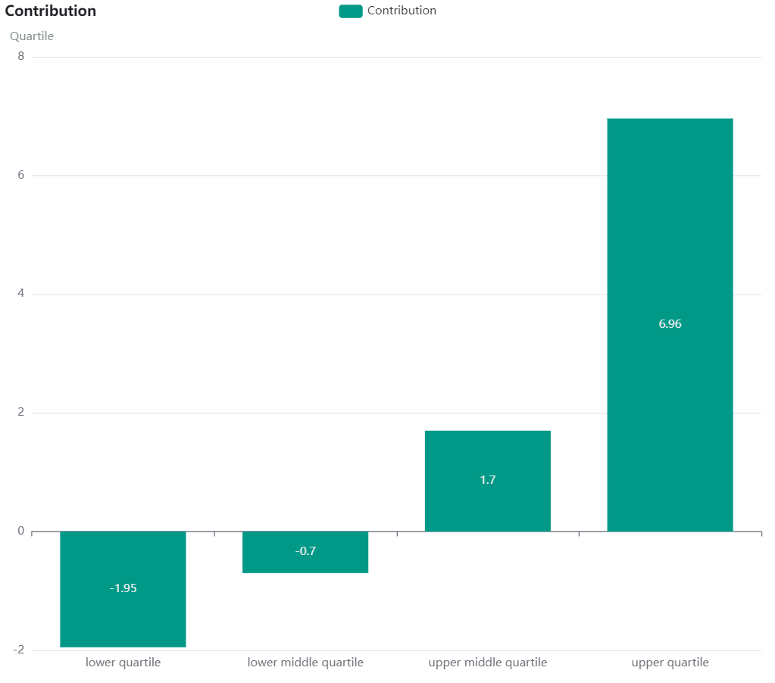

Pay Ranges by Quartiles
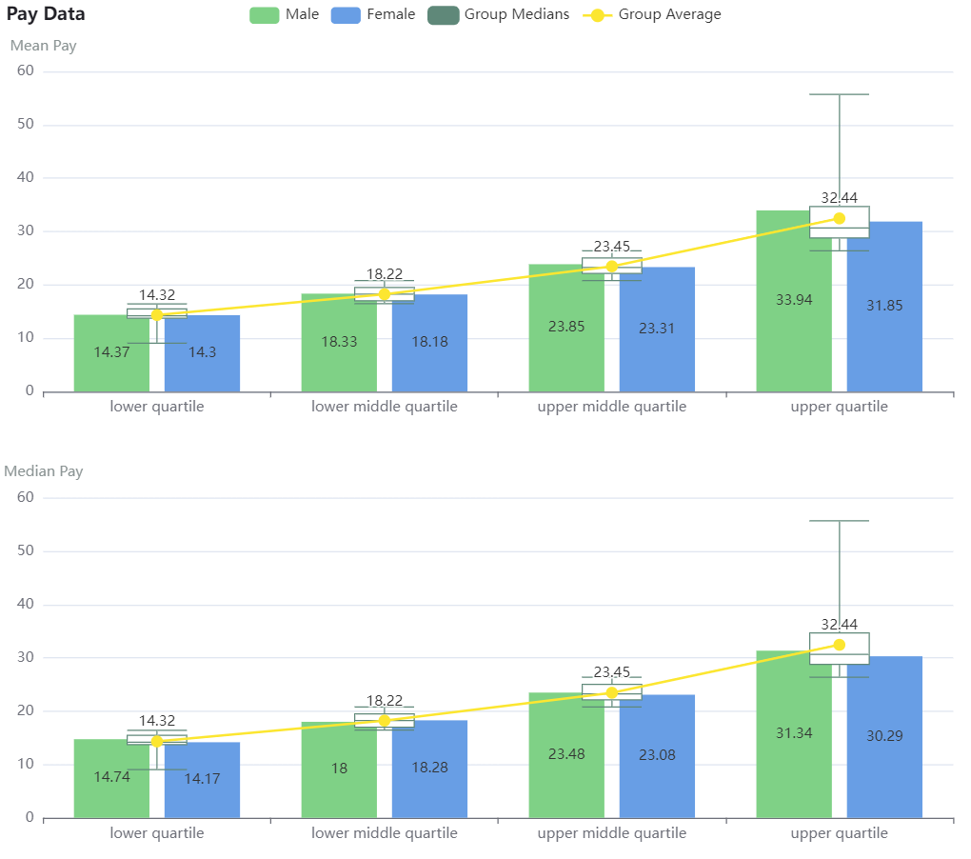

5.2 Our Mean gender bonus gap
St Joseph’s Hospice does not make bonus payments to staff. Consequently, our mean gender bonus is 0%.
Not enough Hospices have declared their Gender Pay Gap for us to provide comparative data at time of writing. This report will be updated when this information is declared.

5.3 Gender Pay Quartiles
St Joseph’s Hospice pay quartiles, percentage in each band (number of employees in each band)

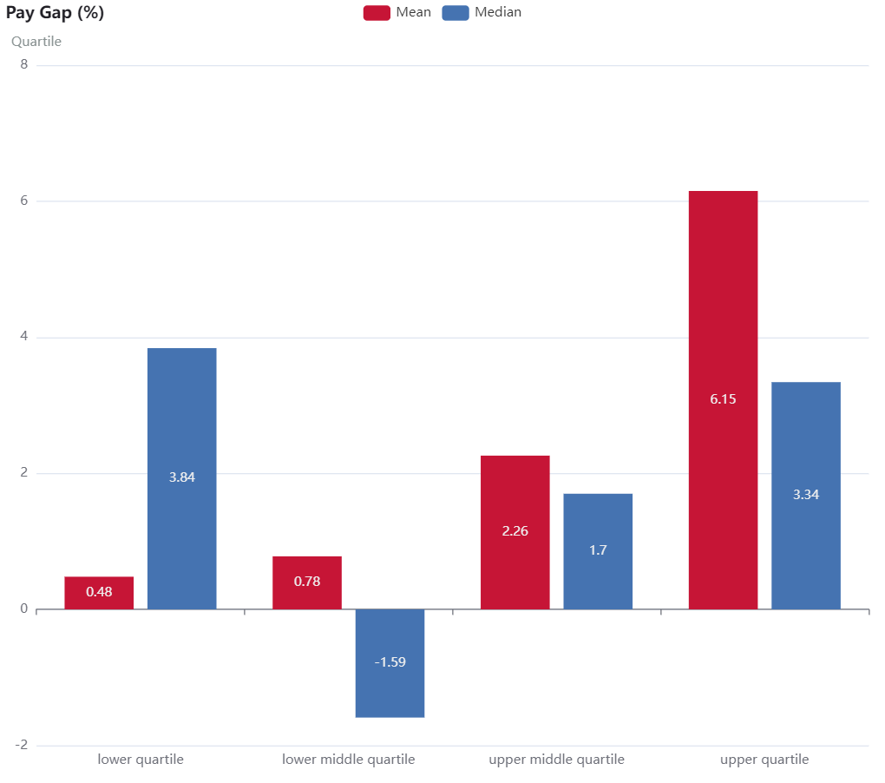

.

Summary
Overall, the hospice does not appear to have a significant gender pay gap. Although the increase in pay gap is an unwelcome trend. It will be important to note the impact of in year work in next years’ pay gap report.
This is the fifth year the hospice has been required to produce a gender pay gap report A more robust data set was provided for the period under report presents an ongoing desire on the part of the Hospice to improve its reporting in this area. The new HR IS system implemented during 2020 has continued to provide the hospice with even more rigorous data set for this report. We continue to develop the capabilities of the HR IS system. However, we will continue to trend analyse data and continue to benchmark the Hospice against other organisations within the sector as well as benchmarking against other hospices in future where possible.
We will continue to invest in rigorous processes for both setting and progressing pay in the Hospice as part of our commitment to managing the talent of the hospice staff team and move to a transparent pay and pay progression system that embeds the Hospice’s values and behaviours framework that the staff team co-created.

